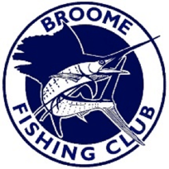
2021 Annual Aggregate Registration Adults $50.00
Juniors $20.00

Name please print |  | Adult | Junior Name (Age) | Amount due
Angler 1
Angler 2
Angler 3
Angler 4

Signature: _____________________________________
Print Name: ____________________________________
Office Use: Amount paid: $ ___________
Received by: ________________

Bring your completed registration form and pay at the Bar at the Broome Fishing Club. Pick up the rules and information and start sending your photos into aggregate@broomefishingclub.com.au

